Here’s [a link](https://drive.google.com/open?id=1ki3VisTPxkd0no_FjtlKtVOiVj70Uj1f) to all of the clips

| expression | # of examples | # of urls |
| --- | --- | --- |
| blink | 18 | 11 |
| chin_touch | 17 | 9 |
| raised_eyebrows | 14 | 9 |
| head_nod | 10 | 6 |
| forehead_touch | 9 | 6 |
| head_shake | 9 | 6 |
| pressed_eyebrows | 9 | 7 |
| back_head_touch | 6 | 4 |
| lean_forward | 2 | 2 |
| squinting | 1 | 1 |
| o_shaped_lips | 1 | 1 |

Here’s some examples of blinks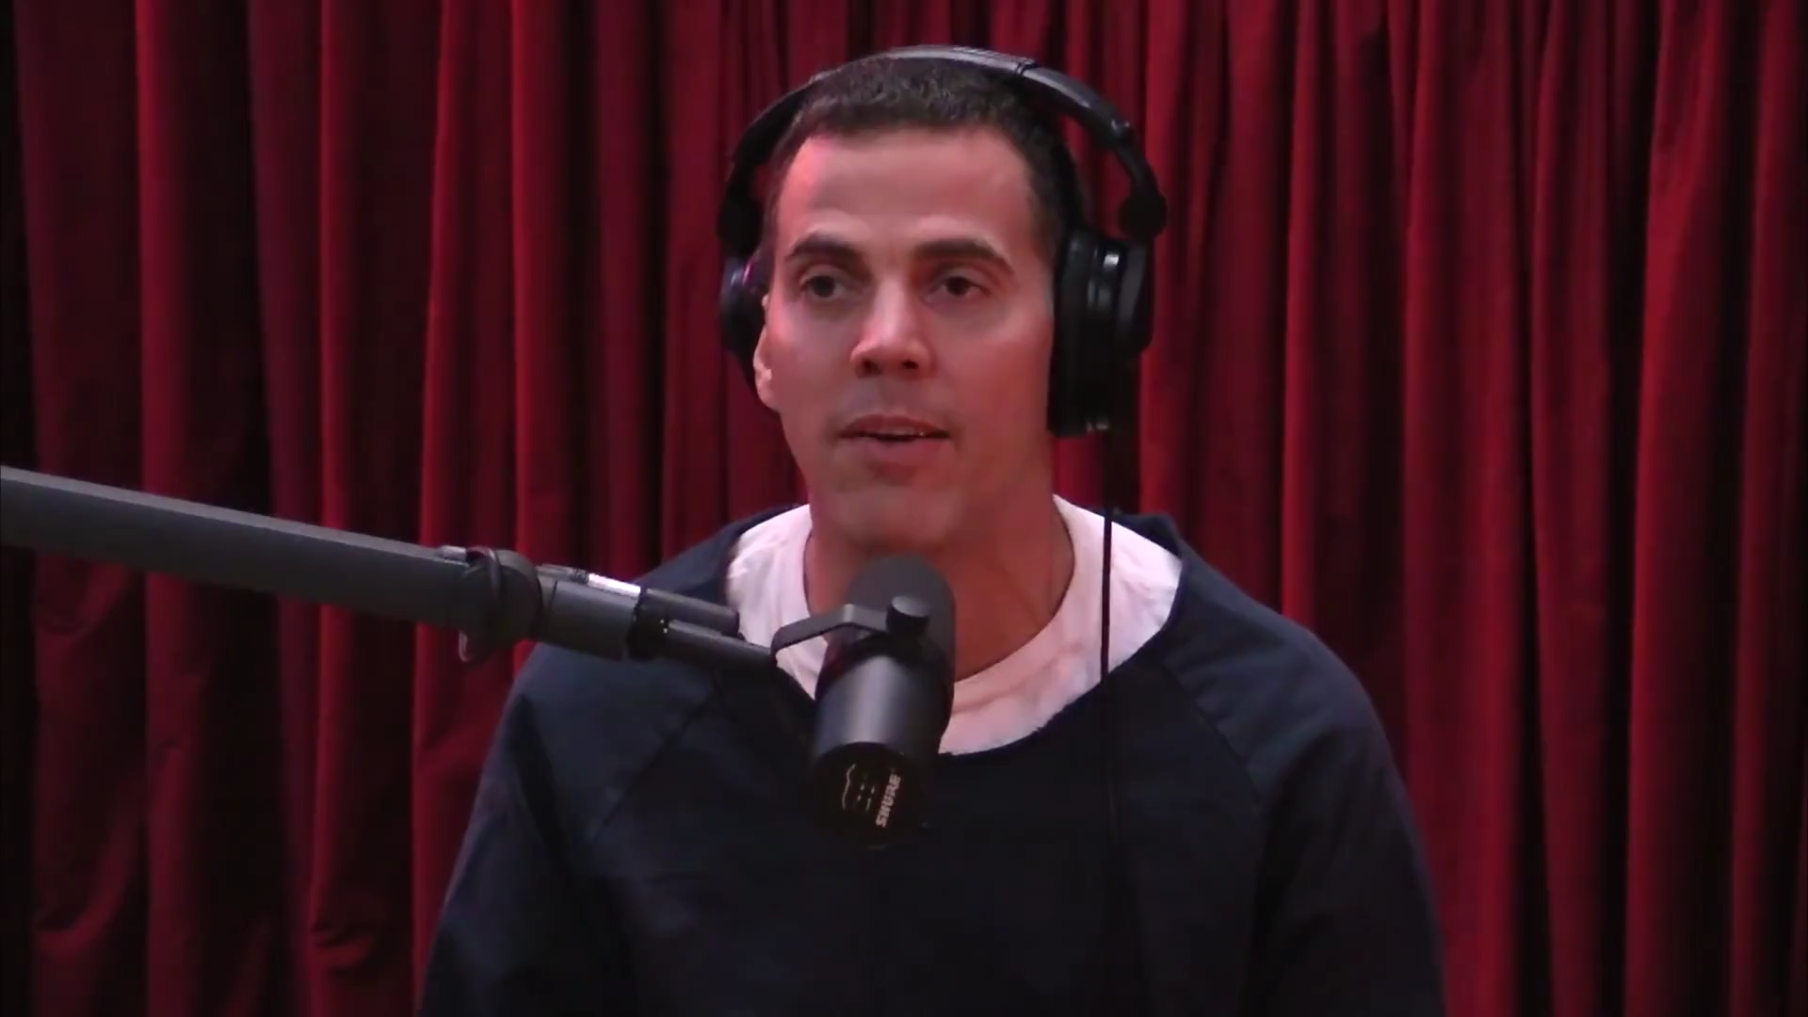

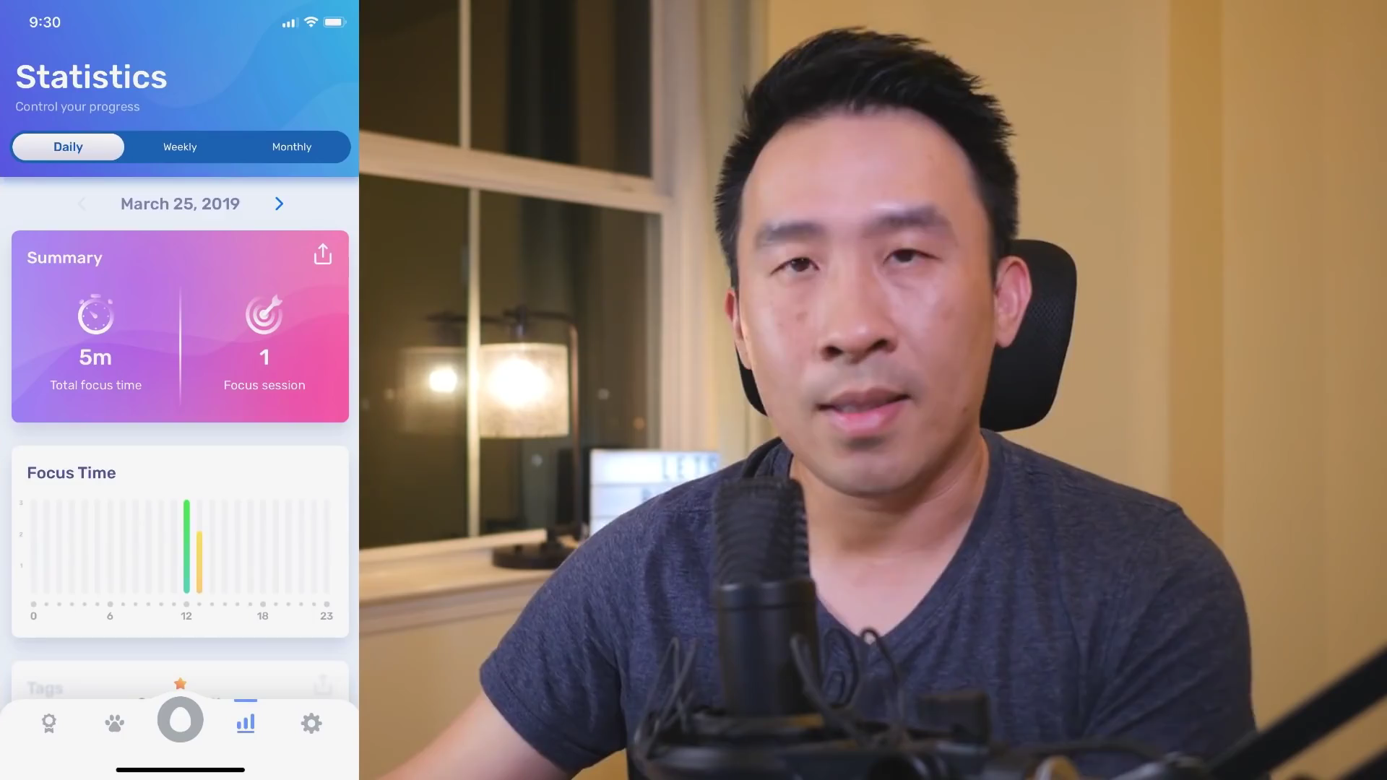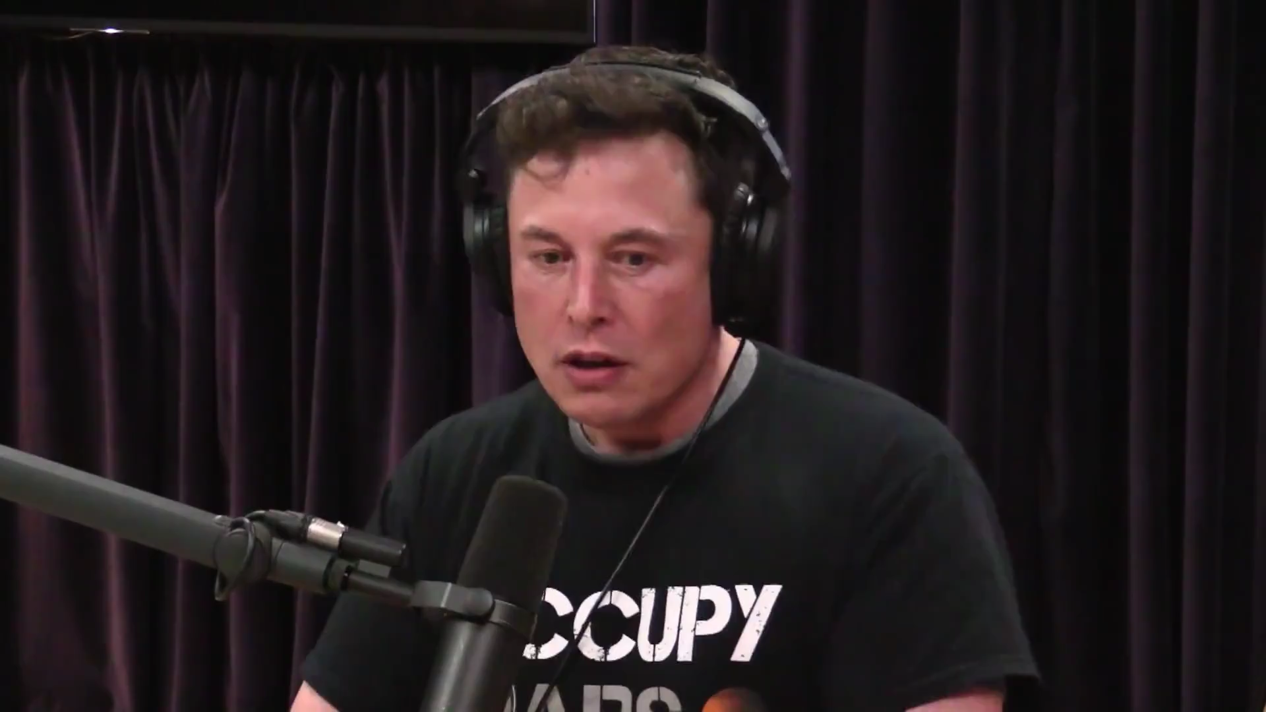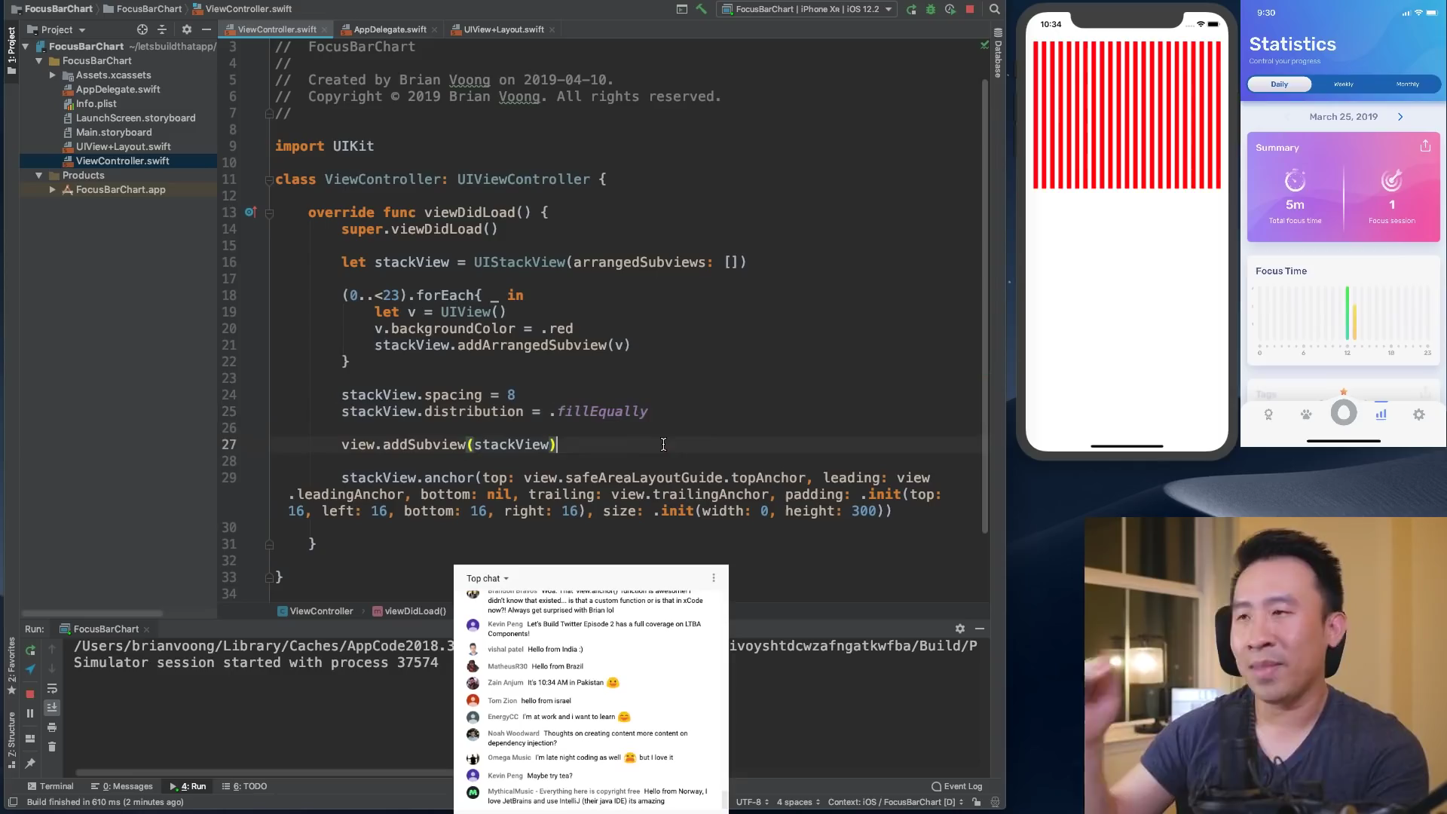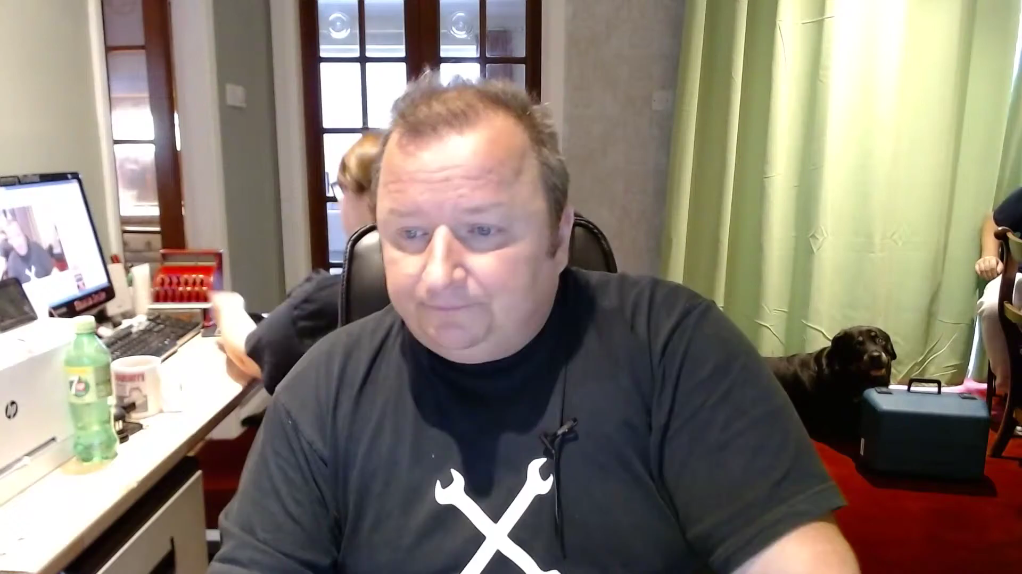

Here are some of the examples of forehead touching

here’s some examples of nodding

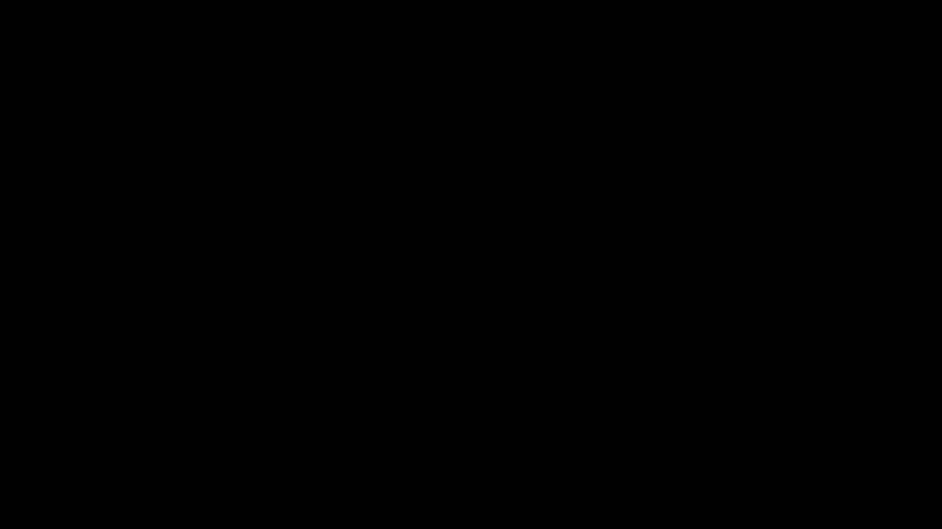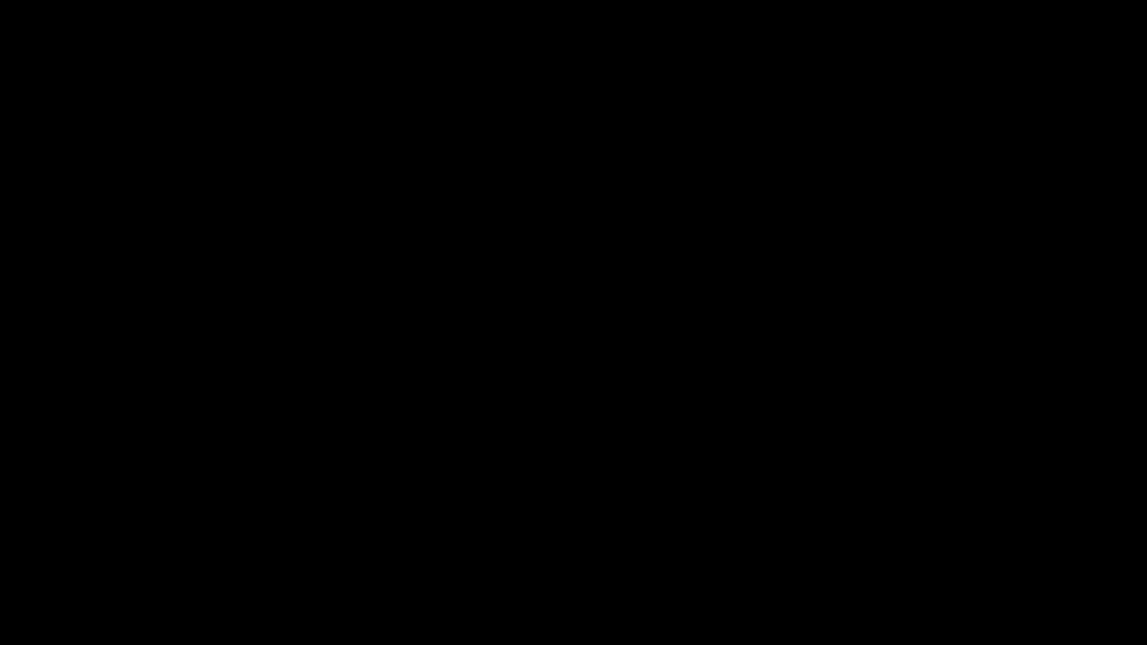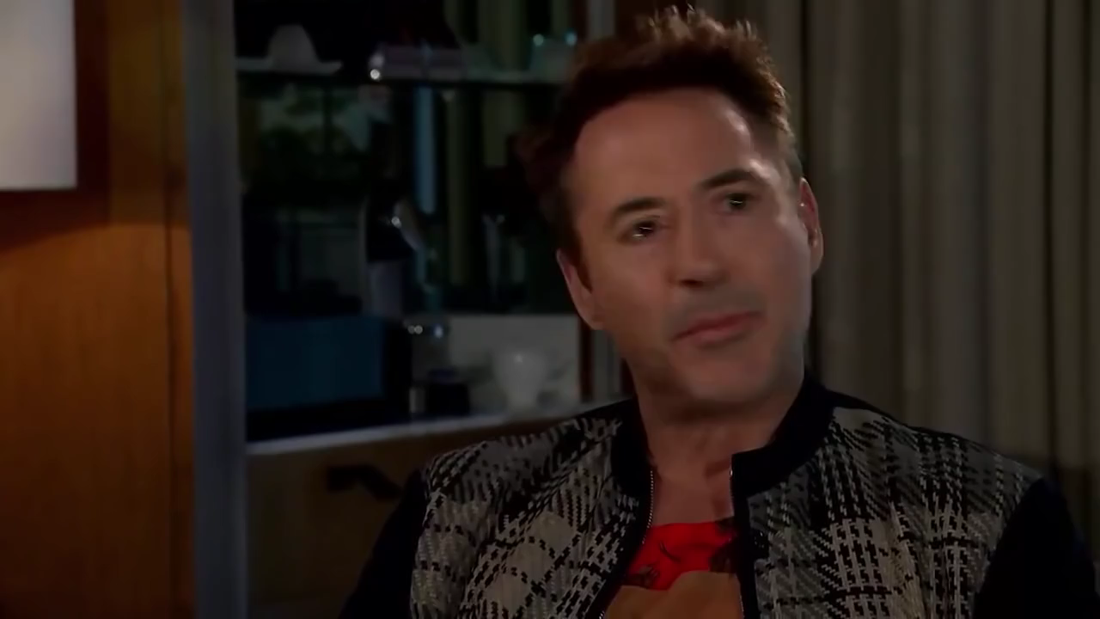here’s some of the examples of head shaking